**Database Name** :- Customer

**DB :** create DATABASE Customer;

**Table 1** : city

create table city

(

id int(100) PRIMARY key,

city_name varchar(200),

lat varchar(200),

log varchar(200),

country_id int(100),

FOREIGN key (country_id) REFERENCES country(id)

)

**Inserting Data** :

INSERT into city(id,city_name,lat,log,country_id) VALUES('1','Berlin','52.520008','13.404954','1');

INSERT into city(id,city_name,lat,log,country_id) VALUES('2','Belgrade','44.787197','20.457273','2');

INSERT into city(id,city_name,lat,log,country_id) VALUES('3','Zagreb','45.815399','15.966568','3');

INSERT into city(id,city_name,lat,log,country_id) VALUES('4','New York','40.730610','-73.935242','4');

INSERT into city(id,city_name,lat,log,country_id) VALUES('5','Los Angeles','34.052235','-118.243683','4');

INSERT into city(id,city_name,lat,log,country_id) VALUES('6','Warsaw','52.237049','21.017532','5');

**Table 2** : customer

create table customer

(

id int(100) PRIMARY key,

customer_name varchar(200),

city_id int(200),

customer_address varchar(200),

next_call_date varchar(200),

ts_inserted varchar(300),

FOREIGN KEY (city_id) REFERENCES city(id)

)

**Insert Data :**

INSERT INTO customer(id,customer_name,city_id,customer_address,next_call_date,ts_inserted)VALUES('1','Jewelry Store','4','Long Street 120','2020-01-21','2020-01-09 14:01:20.000');

INSERT INTO customer(id,customer_name,city_id,customer_address,next_call_date,ts_inserted)VALUES('2','Bakery','1','Kurfurstendamm 25','2020-02-21','2020-01-09 17:52:15.000');

INSERT INTO customer(id,customer_name,city_id,customer_address,next_call_date,ts_inserted)VALUES('3','cafe','1','Tauentzienstrabe 44','2020-01-21','2020-01-10 08:02:49.000');

INSERT INTO customer(id,customer_name,city_id,customer_address,next_call_date,ts_inserted)VALUES('4','Restaurant','3','Ulica Lips 15','2020-01-21','2020-01-10 09:20:21.000');

**Table 3** : country

create table country

(

id int(100) PRIMARY key,

country_name varchar(300),

country_name_eng varchar(300),

counry_code varchar(200)

)

**Data Inserting :**

INSERT into country(id,country_name,country_name_eng,counry_code) VALUES('1','Deutschland','Germany','DEU');

INSERT into country(id,country_name,country_name_eng,counry_code) VALUES('2','Srbija','Serbia','SRB');

INSERT into country(id,country_name,country_name_eng,counry_code) VALUES('3','Hrvatska','Croatia','HRV');

INSERT into country(id,country_name,country_name_eng,counry_code) VALUES('4','United States of America','Unitaed States of America','USA');

INSERT into country(id,country_name,country_name_eng,counry_code) VALUES('5','Polska','Poland','POL');

INSERT into country(id,country_name,country_name_eng,counry_code) VALUES('6','Espana','Spain','ESP');

INSERT into country(id,country_name,country_name_eng,counry_code) VALUES('7','Rossiya','Russia','RUS');

**Query**

**Task -1:**

SELECT country.country_name_eng, city.city_name, customer.customer_name FROM country LEFT JOIN city

ON country.id=city.id LEFT JOIN customer on country.id=customer.id;

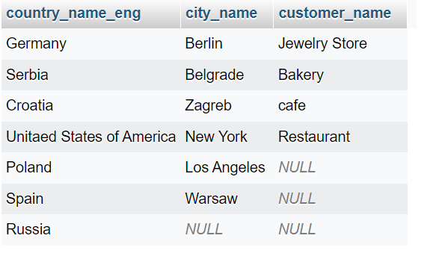

**Task – 2:**

SELECT country.country_name, city.city_name, customer.customer_name FROM city LEFT JOIN customer on city.id = customer.id

INNER JOIN country on city.id = country.id;

